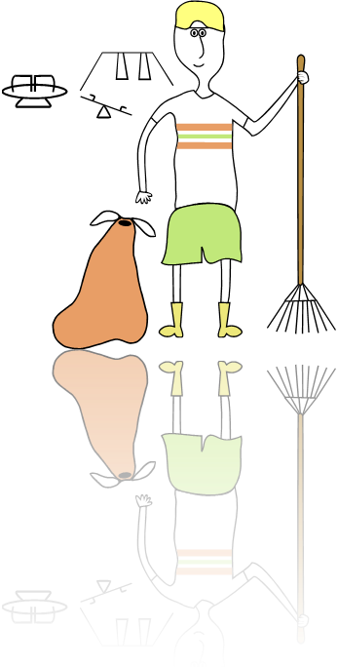
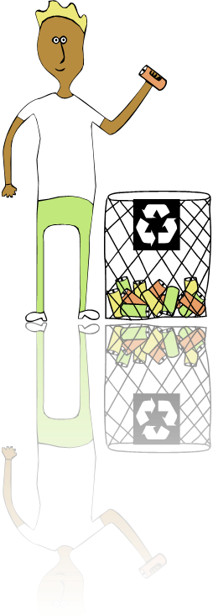
Muirhead Flats
★ Clean up
Skip located at Scott Crescent,
No tyres, fridge freezers,
paint or asbestos
Please do not leave items outside skip if closed!



