TROON COMMUNITY COUNCIL MEETING
TUESDAY 6th December – 7pm
COUNCIL BUILDING
Minutes

- SEDERUNT

Name | Attended | Absent | Apologies
Frances Carson (FC) | x
David Carson (DC) | x
Walter Barr (WB) | x
Robert Milligan (RM) | x
Douglas Graham (DG) | x
Nicky Power (NP) |  |  | x
Anne Cameron (AC) |  |  | x
William Muir (WM) |  |  | x
Ian Wilson (IW) | x
Ian Girvan (IG) |  |  | x
Andrew Girvan (AG) | x
Rob Shirley (RS) |  | x
Brian Phillips (BrP) | x
Ian Knight (IK) | x
Sarah Knight (SK) | x
Philip Saxton (PS) SAC | x
Kenneth Bell (KB) SAC | x
Bob Pollock (BP) SAC | x
Craig McKay (CMcK) SAC | x
Paul Scully (PAS) SAC L |  |  | x
George Mulveney (GE) | x
Alistair Milton (AM) | x

- CHAIRPERSONS WELCOME.

The chair welcomed both the people from Network Rail and Calmac

- APPROVAL OF MINUTES

- Proposed by Brian Philips
- Seconded by Robert Milligan

- Network Rail – Update on Troon Station.
- Stephanie Pelc and Owen Campbell from Network Rail.

Owen Campbell Network Rail

OPTION 2 has been selected

Meeting with SAC will be ready for the Open Golf.

Changing places toilet included
Design will be ready late January
Planning application February for glass canopy
Work at station started on 19 November working on Saturday nights.
Spring 23 Canopy work will start
Car park on Platform 1 will be closed. No other parking has been secured
Summer 23 Main station building work starts
Spring 24 platform work starts

Questions
Craig Changing toilet available -Owen Yes
Andy Raising Platform + defibrillator – Owen Ramps available not sure about defribrillator
Kenny Parking issue - Owen we will get back on that
Ian will station be manned - rail not sure yet

- Arran Ferry Update.
- Stuart Cresswell Port Manager ABP, Transport Scotland and CALMAC.

Stuart Cresswell Port Manger

Checking Booth
Parking for 350 cars
Arran House now Calmac lighting and walkway all completed
To do
Signage and Pay and Display will be finished JUNE/JULY 2023
Timetable Jan/Feb
Morrison Stop
Ferry 2-5 YEARS
Ferry will run 4-7 times a day
Calmac direct ticket Glasgow-Arran – Calmac will get back to us

- ACTION POINTS FROM PREVIOUS MEETING.

AP1 - PS to check poor postal service with local Post Office manager (carried over from October meeting).
Apology letter sent. Completed

AP2 – BP to ask for update on letter to CEO SAC re- assistance in helping cost of the return Model Ships.
Draft letter for model ship not sent. Continued

AP3 – BP to check is lights can be stored in SAC premises. Completed I undertook an action at the last TCC to check to see if the Troon Xmas lights could be stored within the Town Hall or elsewhere. Officers advise that the Council has been reducing the amount of office space it owns and there is now no storage capacity to hold xmas lights, other than those in Ayr which are owned by the Council. The Council will also not take responsibility for holding property owned by a third party. I am also advised that the funding application for the purchase of lights makes it clear that community groups are responsible for arranging their own storage.
Xmas lights Storge container £100 month land rent £1000 to buy round table share
Action Point Ask Nicky
Bob Location for container to be investigated as SAC will not store xmas lights
Dougie write to council why not store lights. Continued

AP4 - DC to assess interest in setting up Heritage Centre subcommittee.

AP5- BP to check over issue of licences. Completed BP has spoken with the Head of Legal Services who advises that she has been liaising with George Mulveny on the two certificates. She will check with the team processing them, but at present she understands they are still waiting for required information which was asked for in mid-October including certificate of insurance for the PLI of £5 million, and also details of the proposed funfair rides, safety docs etc.
She advises that a parade notification can usually be dealt with pretty quickly as long as there are no issues with Police/ARA, and she will check the progress of any applications submitted and contact George directly if there are any issues. Completed

AP6- PAS/CMK to look at providing a Skip Completed I've checked with Paul Scully about the clean-up day as discussed at last week's meeting. I also asked about whether in the longer term there are any lessons we can learn from other similar areas where furniture and white goods build up over time and have to be cleared. I could see there was some resistance at the meeting to providing this support, but I am well aware that most of the residents don't have the means to pay for £25 bulky uplifts. I would prefer to find a way to somehow deal with these items on an ongoing basis rather than having to rely on periodic skips and clean-up days.

Paul advised that there is no easy fix and that there are areas throughout south Ayrshire that we need to do yearly clean ups due to lots of different factors.

He has tied in with the Police and is meeting the fire service next week about being involved on the day, and also doing a leaflet drop on the day with info on Crime Stoppers, reporting fly tipping and fire safety.

Paul is waiting to hear from Waste Management about when he can hire a skip and then he will come back to everyone.
I'm keen that this is able to happen as soon as possible as with the dark nights we're going to have less and less daylight time to fill the skip.

Further update from Bob Pollock - Community Safety have arranged to do a clean-up at Muirhead flats next Tuesday the 29th Nov from 9:30-3pm, we will also do a leaflet drop on Crimestoppers, reporting fly tipping, ASB and fire safety. Completed

AP7- PAS to speak to environmental health about stray dogs. Completed

AP8– BM to invite NWR and Scotrail to December meeting. Completed letter sent received confirmation that they will attend meeting. Completed

- SECRETARY’S REPORT Appendix A.

Apologies I will be on holiday and will not be able to attend the meeting on 6th December 22.

Correspondence

Please see below all correspondence received since our November meeting that has been passed onto members.

- Approved October minutes sent to SAC.
- Wintertainment Certificates-Licences’. update forwarded by Bob Pollock.
- AP7 Letter sent to O Campbell and S Pelc inviting them to the December meeting (sent 4th November).
- Invite sent to S Cresswell Port Manager APB to attend meeting.
- Marr College incidents update forwarded by Bob Pollock.
- Accessible Ayr Events update forwarded by Bob Pollock.
- HSCP Communications Email update forwarded by Anne Cameron
- School closures Thursday 24 November update forwarded by Bob Pollock.
- NHS A & A Dementia Support App update forwarded by Anne Cameron.
- Winter Warmer Event - 9th December 2022 Somerset Park, Ayr forwarded by Bob Pollock.
- Health & Social Care Partnership - Locality Planning Partnership Small Grant Funding update forwarded by Anne Cameron.
- New date for Troon Carers Event forwarded by Anne Cameron.

Information forwarded for Web Page update.

- HSCP Communications Email
- Active Travel Improvements on the A77 (Bogend Toll - Symington

Billy Muir
Secretary
wmuir204@gmail.com

- TREASURERS REPORT Appendix B.

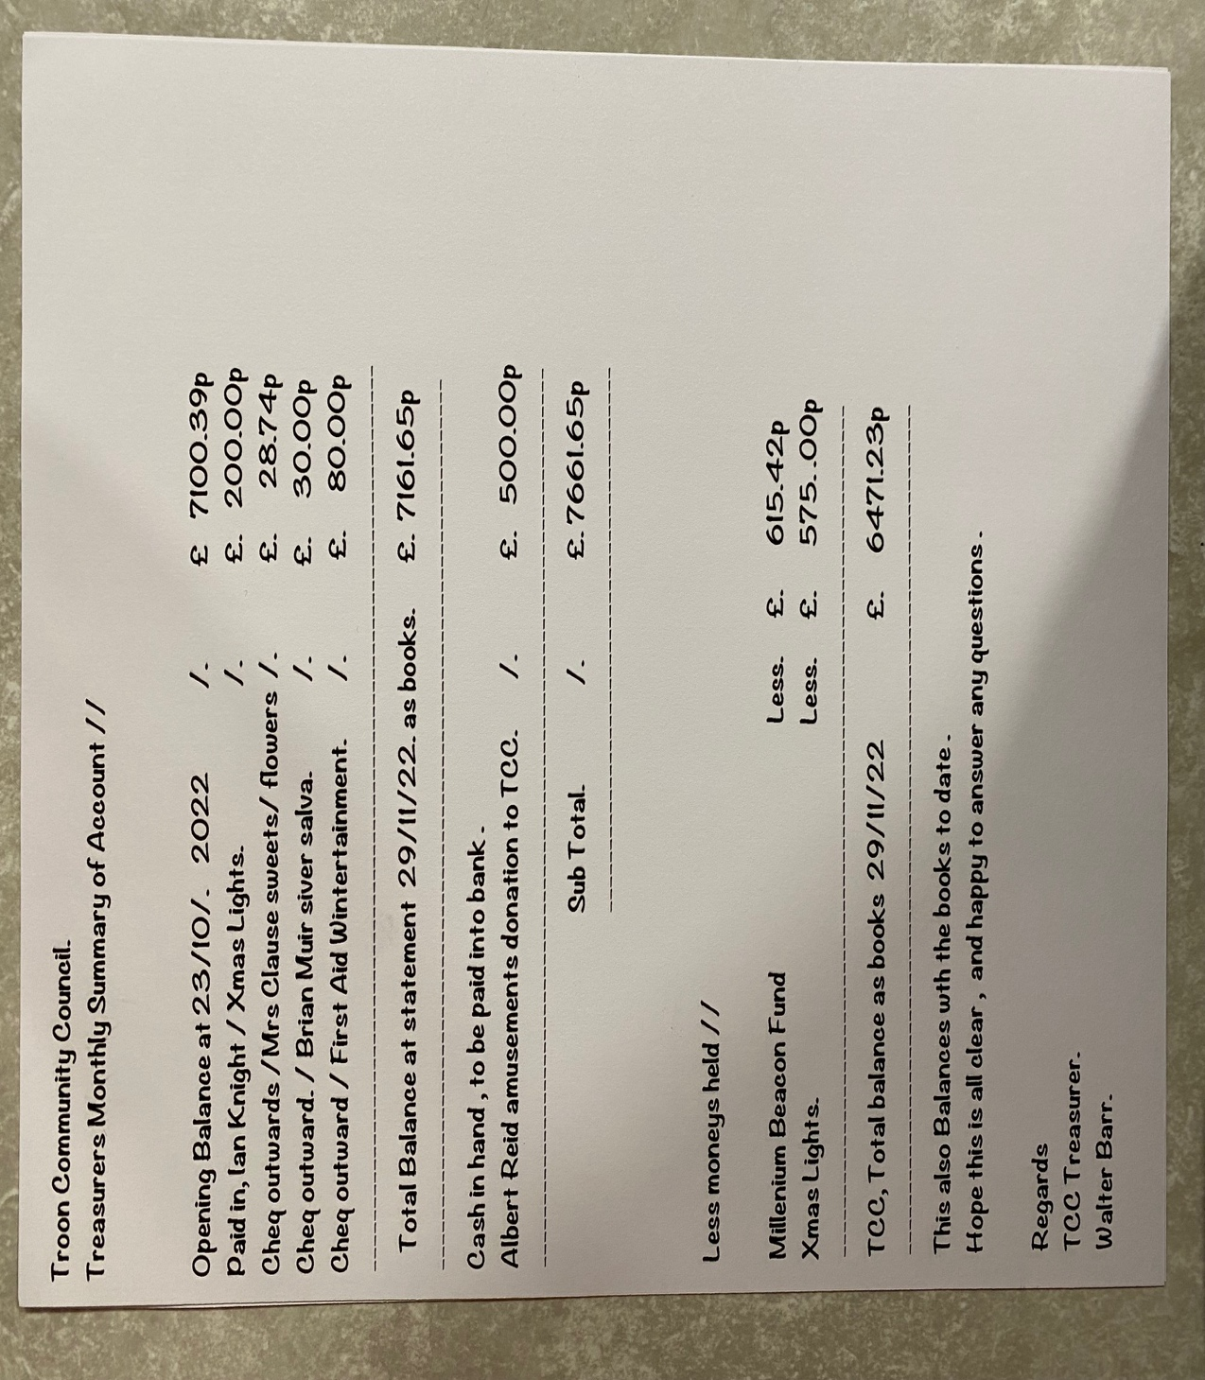

- POLICE REPORT Appendix C.
N/A

- TCC REPORTS.

- Youth Forum.
- Events Forum.
- Wintertainment see Appendix D
- Licensing.
- Planning
- "Troon Heritage" Project See Appendix E Troon Together report - "Community Action Plan" page 87. The full report can be found at https://www.south-ayrshire.gov.uk/article/28255/Troon-Thriving-Places
- ARA North Drive Cycle Route.
- Web Page & email update Appendix F

Just to let you know that Linda has now separated the web hosting for TCC from her other business.

I asked Linda to set up an email treasurer@trooncommunitycouncil.co.uk through the allsimple domain host. The annual account for the web hosting will now be sent direct to Walter on this email. The actual monies will be taken direct from the TCC bank account in future.

I have also created the other suggested and agreed emails which are:-

  - chairperson@trooncommunitycouncil.co.uk
  - secretary@trooncommunitycouncil.co.uk
  - allcouncillors@trooncommunitycouncil.co.uk
  - admin@trooncommunitycouncil.co.uk

Passwords will be provided to the relevant councillors at the meeting and not online for security.

These email accounts can then be accessed through signing in to https://webmail.allsimple.net/

There was no extra cost for these email addresses.

- SAC REPORTS & DISCUSSION

- Bob Pollock

- Contact the Council’s Criminal Justice Team to see if they could assist with flooding issues at Fullarton Woods through the Community Payback Scheme.

Criminal Justice advise that they are already liaising with the Ranger Service on this issue, and they will liaise directly with the Friends of Fullarton Woods. (They are also looking at flooding issues, in conjunction with the Ranger Service, in the burn at the rear of Marr College).

- Contact Criminal Justice regarding the Community Payback Scheme assisting with projects at the Bradan Road Sheltered Housing Complex.

Dean Barlas from Criminal Justice will contact Ian Wilson directly – complete.

- Contact ARA regarding the flashing 20mph lights at Marr College.

Email sent to ARA asking for repairs to be expedited. Awaiting a response and will update when I get it.

- Contact ARA about traffic/pedestrian signage between Troon Harbour and Railway Station for the Arran Ferry transferring to Troon in summer 2023.

Email sent to ARA requesting that they liaise with Calmac/ABP/Railtrack/Transport Scotland on signage issues, if not already doing so. Awaiting a response and will update when I receive one.

- Contact ARA regarding single sign at Jubilee Road directing traffic towards the town centre for golf. Confusing as there is no further signage, nor does it specify which course(s) it refers to.

Signage is probably redundant as most people now use satnav. Email sent to ARA asking if the sign is still required, or if additional signage is required. Awaiting a response and will update when I receive one.

- Pursue the possibility of having a location/lease arrangement for a shared storage container between the Round Table/Troon CC, to be located on Council land.

The Council Estates Department have provisionally confirmed that they would consider such a request. Nicky Power emailed to see if the Round Table wish to pursue this, and if so I will continue to liaise with Estates. Awaiting a response from Nicky and will update as more information comes to light.

- Pursue a response to the letter from the CC to the Chief Executive, SAC, asking for assistance in recovering the ships model from Orkney.

Director delegated responsibility for responding on behalf of the Chief Executive contacted and asked to expedite a response, if not already sent. Awaiting a response and will update when I receive one.

I think George’s suggestion of having a rep from Troon Litter Crew address the pupils is a good one as it would give them a different perspective on the issue than what they can get from teachers. I’ll wait to see if anything else came out of the Parent Council but will be happy to follow up with Troon Litter Crew to see if they would be happy to try this.

- Phil Saxton

N/A

- Craig McKay

- I have managed to check with Paul Scully about the postponed skip at the Muirhead flats. He has now requested a skip for Tuesday 10th January (still to be confirmed), which may be good timing to deal with items that people have cleared out over the holidays. On the disposal of white goods, he doesn’t have a specific answer but is going to see if the fridges, etc. already there can be picked up.

- I didn’t make it along to the Marr College Parent Council tonight as I was watching my daughter. I have however had the following response from George Docherty on the litter issue:
- PC Harrower and I visited both the Co-op and KeyStore around two weeks ago. The Co-op seems to have become very popular this term – in the past we had no similar issues over towards the fields. Less pupils are going towards the town through Browne Avenue or visiting the Keystore in Muirhead and the litter situation there has improved (perhaps with the exception of the gardens at the Muirhead flats).

- We are still undertaking litter picks and routinely remind pupils at Assembly about litter. Last week a gentlemen came into the school grounds and emptied a large bag of litter in front of one of our emergency exits. PC Harrower is looking into this, though I had hoped the member of public might have tried to engage with us in a positive way.

I’m attending the U18 Rugby Final this evening and Mr Ward will be attending Parent Council in my place. I have copied the Parent Council email address in this reply and hopefully we can find some time to discuss potential solutions. Last term PC Harrower tried to work with the Keystore Staff to undertake a quick litter pick after the lunch service, but the staff were not keen. Both stores take in considerable profit from the young people (and their parents) and I feel it would be helpful to continue to engage with them about the litter situation.

As we all likely appreciate, banning pupils from leaving school at lunch will not be achievable or indeed be in the best interests of our local stores. I wonder if the Troon Litter Crew or Friends of Fullarton Woods might be willing to come in to speak to pupils with school staff in an effort to educate pupils on the impact of littering. I have no doubt that the changes to school meals service and the cost in comparison to what local shops are offering is only exacerbating the problem.

Perhaps there may be some further ideas from the meeting that we can take forward and I’ll certainly ask Iain to feedback to me tomorrow.

- Kenneth Bell

Find out whether Customer Services within Municipal Building is going to open more often that 1 day per week.

Look into why Muirhead Community Centre can’t be booked by individuals / groups at the weekends.

FYI, I have emailed both Service Leads in respect of the above actions requesting that they get back to me before the next TCC meeting in January. Once I have received an update from them, I will send it on.

- OPEN FORUM.

- Friends of Fullerton help clearing the burn – community payback
- Send flowers to Eric’s family

- AOCB

- Letter sent ton Albert thank you £500
- £100 sent to pipe band
- £50 sent to Parish Church
- Dates for taxi 21st June
- Wintertainment 19th November

- CHAIR CLOSES MEETING.

- Date of next meeting.

