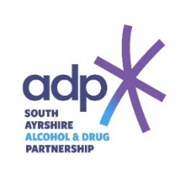

Stigma Awareness Workshop
Booking Form

Name
Designation
Service / Organisation
Email
Telephone

Please note each session will last approximately 3 hours.

Please select a preferred, second & third choice date to attend.
Date | Time | Venue | Please mark 1st 2nd & 3rd preference
Tuesday 23rd May 2023 | 9:30am – 12:30pm | 8 Wellington Square, Ayr.
Tuesday 27th June 2023 | 9:30am – 12:30pm | 8 Wellington Square, Ayr.
Tuesday 29th August 2023 | 9:30am – 12:30pm | 8 Wellington Square, Ayr.
Tuesday 26th September 2023 | 9:30am – 12:30pm | 8 Wellington Square, Ayr.
Tuesday 24th October 2023 | 9:30am – 12:30pm | 8 Wellington Square, Ayr.
Tuesday 28th November 2023 | 9:30am – 12:30pm | 8 Wellington Square, Ayr.

Please return your completed booking form to adp@south-ayrshire.gov.uk by Friday 19th May 2023.

