TROON COMMUNITY COUNCIL MEETING
TUESDAY 7th February 2023 – 7pm
COUNCIL BUILDING
AGENDA

- SEDERUNT

Name | Attended | Absent | Apologies
Frances Carson (FC) | x
David Carson (DC) | x
Walter Barr (WB) | x
Robert Milligan (RM) | x
Douglas Graham (DG) | x
Nicky Power (NP) | x
Anne Cameron (AC) |  |  | x
William Muir (WM) | x
Ian Wilson (IW) | x
Ian Girvan (IG) |  |  | x
Andrew Girvan (AG) | x
Rob Shirley (RS) Missed 3 meetings. Off.
Brian Phillips (BrP) | x
Ian Knight (IK) | x
Sarah Knight (SK) |  |  | x
Philip Saxton (PS) SAC | x
Kenneth Bell (KB) SAC | x
Bob Pollock (BP) SAC
Craig McKay (CMcK) SAC | x
Paul Scully (PAS) SAC L | x
George Mulveney (GE)
Alistair Milton (AM) | x

- CHAIRPERSONS WELCOME.

FC welcomed all to the meeting. She explained that the open forum was moved to the beginning of the meeting.

FC announced that Joe Miller had been chosen to receive the Civic Award and had accepted this.

- OPEN FORUM.

FC asked counsellors to deal with an issue over rubbish bins being kicked over by school children.

PC stated that he would take this on board. He will e-mail campus officer regarding this.

KB said he was aware that the headteacher at Marr knows about this.

Mr Eaglesham asked for an update on cycle path in North Drive.

CMCK said there was no update no update available.

Mr Eaglesham asked about a cycle path is under construction in Dundonald does it link up with Loans.
DG stated that it would not link up.

CMCK stated that eventually it would link up.

Mr Eaglesham asked if there was feedback published.

FC stated that she thinks there was feedback.

PS stated that he did not recall any feedback.

Mr Eaglesham stated that he had discussed this with a person from ARA.

PS stated that it was muted that a speed limit was not suitable, and we need to wait for the update.

- PRESENTATION from Margaret Scott. Community Wealth Building Officer.

The presentation covered the progress that has been made in ensuring local business benefit from the procurement funding that is available.

Explained how traders in Ayr have come together to help improve their local area. She also said that a similar plan could be set up in Troon.

She explained that there was funding left to be distributed and they hope to support Heritage business planning.

Margaret provided her e-mail address should anyone want to contact her at Margaret.Scott1@southayrshire.gov.uk

IG asked about a community Hub would there be help available for this.

MS agreed to meet with him to discuss.

DC if suppliers gain a contract how do they get information.

MS agreed to send information to the Secretary.

FC raised an issue about spare ground at Muirhead being used as a basketball court. She asked if this would be suitable for funding. She also asked about a softball unit.

MS stated that funding was meant for entrepreneurs.

DG asked if funding would be available for funding the model ships.

MS this is important for history of Troon. She advised that she would be happy to meet to discuss.

DC would be useful to have a meeting. WE could ask this to the wish list if a local contractor could bring the ship back to Troon.

- APOLOGIES

- Ian Girvan
- Anne Cameron
- Sarah Knight

- APPROVAL OF MINUTES

Proposed by – Douglas Graham
Seconded by - Robert Milligan

- SECRETARY’S REPORT Appendix A.

There was some debate over the Civic Award, prior to the TCC January meeting,, a vote took place however after some discussion it was agreed that a vote would be taken at the next TCC meeting to select a candidate for the award.

There was no Quorum at the January meeting. A consultation took place.

Correspondence

Action Points from 10th January meeting.

AP 1 Bob Pollock to check with SAC officer.

Completed as advised by Bob Pollock.

Laura Kerr, Service Lead for Art and Museums, will get in touch with Frances to discuss the ships models currently held by the Council. Laura is also interested in supporting the digital heritage project and will get in touch with George directly to discuss.

AP 2 Bob Pollock to contact Police re attendance at TCC meetings.

Completed as advised by Bob Pollock.

I have spoken to Chief Inspector Kevin Lammie, the local Police Area Commander about representation at the CC. Kevin advises that coincidentally they have been working on a strategy for renewing liaison with Community Councils. He is attending the meeting in County Buildings next week with the Chairs of the Community Councils and he will probably raise his proposals for discussion at that.

BM AP3 to send AM list of SAC counsellors e-mail addresses.

Completed as advised by Billy Muir.

e-mail addresses were forwarded to Alistair as requested.

e-mails

- Ayrshire Cancer Support Children and Young People Service - Workshops for young people aged 12 – 25.
- Local Police Plan Consultation [OFFICIAL]
- Reminder: Troon & Villages Small Grant funding up to £1000

Bob Pollock updates over the following -
Police attending the TCC meetings.
Update on Model Ships and support for Troon Heritage.
Update over Bob Pollock over potential support from Marr College and Ayr College.
Update over Regarding the Phase 3 cycle track
Update over ARA advise that a Roads Engineer has been tasked with investigating the flooding issues on Kilmarnock Road
Update over ARA advise that following consultation with Ian McKnight the xma lights.
Update over Margaret Scott from the Council’s Regeneration and Community Wealth Building Team will attend the next meeting of the TCC.

Craig MacKay sent the following updates.

Community skip now arranged by Paul Scully for Muirhead flats next Tuesday
VASA published a list of "Cosy Spaces" where those unable to heat their homes can get some warmth.
Safety concerns raised about Academy Street / Church Street junction
Flashing lights on Dundonald Road for Marr College have been malfunctioning since the summer
Following repeated vandalism at the new Barassie Shore toilets, these are now closed at night.

Update Muirhead Leisure Centre from Kenny Bell

Within Sport & Leisure, we have just come through a Service Review and are currently carrying some vacancies, of which some are within Activity Centres – this contributes to a rationale for Monday to Friday opening, as well as facilitation of existing bookings. As part of the Service Review process I am, at this time, reviewing all operation within the ACs and looking to rationalise this along with the staffing. With that in mind, whilst Muirhead is only operated Monday to Friday currently, this is under review and may change. Further, if there are any specific groups who are interested in discussing a long term booking/let then I’m happy to consider proposals and would endeavour to staff appropriately should this be a viable option. However, given the historical ad hoc nature of bookings I can’t commit to staffing this facility on a Saturday and Sunday in case there are any walk in sporting bookings, for example.

Over the coming months I expect to be able to offer an update on Activity Centre operation and would encourage you to keep in touch. In addition, following your meeting below, if you are aware of any specific groups that are looking to access Muirhead Activity Centre on a regular basis and are currently unable to do so, I’m happy for my details to be passed on to investigate any options.

- Winter Health Care Services forwarded by Anne Cameron.
- Volunteer Events forwarded by Anne Cameron.
- Data Protection Fee information forwarded by George Mulveny.
- Struthers Primary - play area upgrade forwarded by Bob Pollock.
- Volunteer Events forwarded by Anne Cameron and Bob Pollock.
- Vacancies forwarded by Bob Pollock.
- New wheeled-sports zone set for Troon forwarded by Bob Pollock.
- Troon Community Council - Lights Out On Cycle Track [OFFICIAL] forwarded by Bob Pollock.
- Funding Alert - issue 1forwarded by Bob Pollock.
- Free webinar for community councillors to learn more about Community Map Scotland on Microsoft Teams on Friday 10th February at 2pm. Forwarded from SAC.
- Free School Transport forwarded by Bob Pollock.
- SAVE THE DATE: Night at the Oscars forwarded by Anne Cameron.
- Troon Community Drop-In forwarded by Bob Pollock.
- South Ayrshire Council’s annual budget setting - have your say! Forwarded by Bob Pollock.
- Calling All Local Community Groups – Our Community Benefits Wishlist Is Open! Forwarded by Bo Pollock.
- Communications Email forwarded by Anne Cameron.
- Free Webinar for Community Councils with Community Map Scotland - Evening Event added - Wednesday 15th February 2023 6pm. Forwarded by Tracey Whiteford SAC
- Active Communities info for Elected Members forwarded by Bob Pollock.
- Community Wealth Building Consultation forwarded by Francis Carson.
- Calling All Local Community Groups – Our Community Benefits Wishlist Is Open! Forwarded by Bob Pollock.
- Dundonald Camp Request from Hugh Ward.
- Lets Talk...Funding forwarded by Bob Pollock.

Letters.

Notice of election of Troon Community Council members, Appendix D

Letter to Mike Newal Appendix F Francis Carson

Letter from Hugh Ward Appemdix I (Dundonal Camp).

Billy Muir
Secretary
wmuir204@gmail.com

BM advised that he had received an e-mail from SAC regarding how co-optees’ should apply to become full members of the TCC. She also advised that applications must be submitted by Thursday 16th February 2023

- TREASURERS REPORT Appendix B

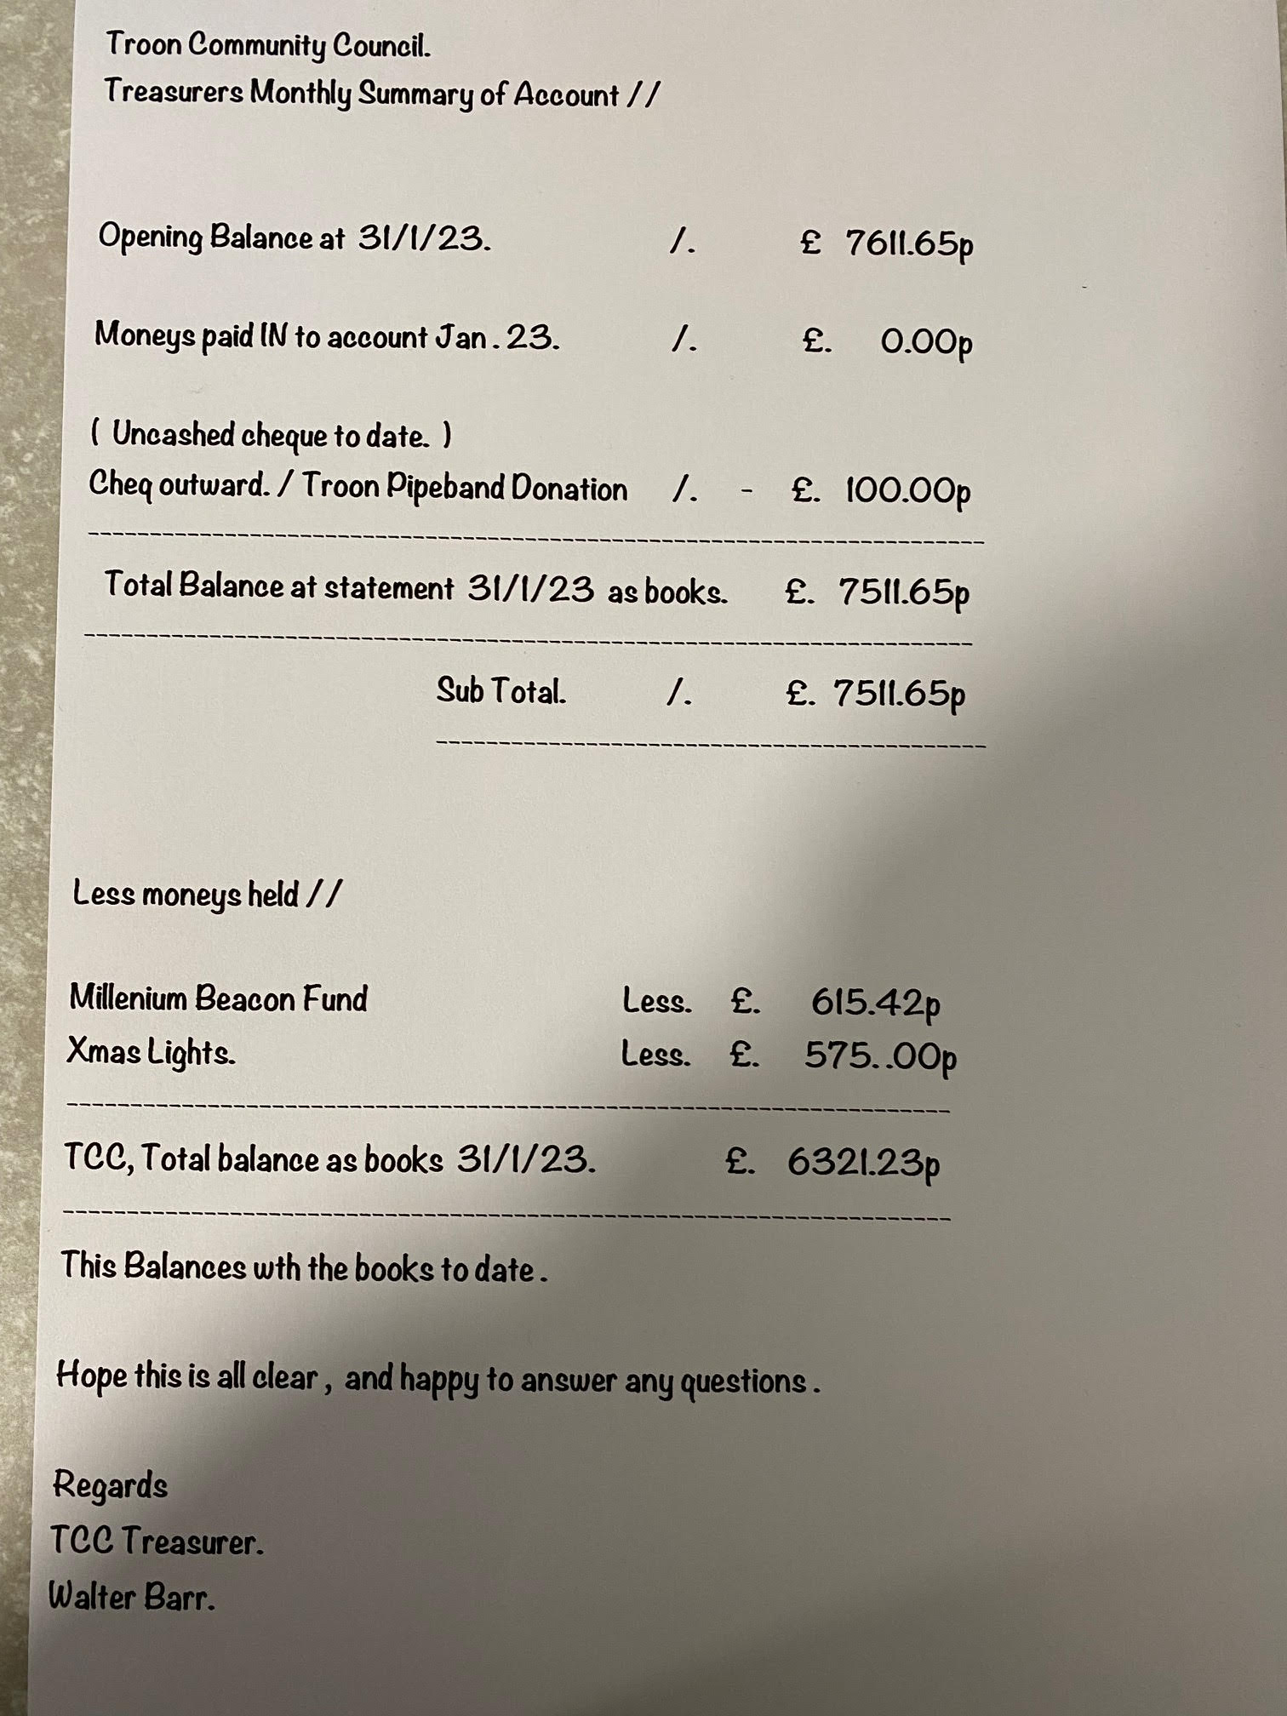

- POLICE REPORT Appendix C

Community Council Meeting: | Troon
Date: | Feb 2023
Officer Attending: | Report submitted
The information below covers the period from 01st December 2022 to 05th February 2023 with details provided in relation to the local priorities highlighted in the 2021-23 Local Police Plan for South Ayrshire.
Specific figures, stats and trends will continue to be provided at the Senior Management Scrutiny Board via the Partnership Panel.
- Serious and Organised Crime – (including Violence, Drug supply, Sexual Crime) | Violence  For the reporting period, officers have dealt with 3 assaults, all were of a minor nature. For one of the assaults this was due to a fall out between friends which escalated resulting in one male being assaulted. Alcohol was also a factor and those responsible were dealt with accordingly.  Drugs Supply  Proactive work targeting drug supply is ongoing, for the reporting period we have received 6 calls from the community providing information in relation to drug activity. In relation to the calls received, information has been pulled and entered into our intelligence database.
- Safer Communities (including Hate Crime, ASB, Domestic Abuse) | Nil  Anti Social Behaviour (ASB)  During the reporting period we have received a high number of calls in relation to calls linked to ASB.  We received 19 disturbance calls, 12 of which required an immediate police response. Officers attended and for a small number of the calls, persons were arrested due to their conduct. These calls were not isolated to a particular area.  There were 14 reports of public nuisance type behaviour and this again related mainly to youths causing annoyance, with no repeat areas of concern being identified for the reporting period. We have received a small number of calls relating to trail bikes / off road bikes being used in the area of Dundonald Road and efforts have been made to identify those involved.  We continue to review reports of noise complaints and neighbour disputes, for the reporting period officers dealt with a high number of calls in relation to this. Work is ongoing to make efforts to resolve the ongoing issues. Work is ongoing between the Police ASB Team and South Ayrshire Council’s Housing team and ASB Team.  Domestic Abuse  This area of policing continues to be an area of focus, officers provide support to victims and ensure with consent of the victim they are referred to support agencies.
- Acquisitive Crime | Housebreaking  Robbery  Fraud | Nil  Nil  Nil
- Community Wellbeing | Substance Use  We deal with a high number of incidents whereby substance misuse in relation to alcohol and or drugs is a factor. We work alongside partner agencies to refer individuals for further support.  Children & Young People  Nothing to report on of note for this meeting.  Welfare Concerns  We continue to respond to a high number of these types of incidents, which often take up a considerable amount of time of officers. These incidents can vary from persons suffering from mental health concerns to elderly members of the community requiring assistance. For the reporting period, we dealt with a high number of incidents with many of them requiring an immediate response. We work alongside partner agencies to deal with the incidents in a timeously manner as possible ensuring individuals speak with the relevant agency.
- Road Safety (Drink / Drug Driving, Speeding, Disqualified / Uninsured Driving) | We continue to receive a number of reports in relation to road safety. These range from speeding complaints, parking complaints, vehicle breakdowns.  Of note, 2 drivers were reported for careless driving, 3 drivers for driving without relevant insurance and 1 driver for driving under the influence of drugs.  Locality Officers also recently carried out a road safety initiative and Troon was included 5 motorists were issued with tickets for driving above the speed limit and 3 were warned. We will look to doing further road safety initiatives in the coming months.
Up-coming events | none
Other Matters / appeals | none

Two Constables attended the meeting.

RM asked about speeding in South Beach area.

- TCC REPORTS.

- Youth Forum.

FC suggested that we write to Marr College to invite someone along.

KB stated that we could look into inviting people who are on the youth parliament.

PS stated it was the captains from the schools who would normally attend the meeting.

KB suggested that we look at other youth organisations who should be considered.

DC asked if it would be possible to create a youth community group who would be self-governing and would appoint people to attend TCC. He understands that

AP1 PS to check with community youth forms.

- Events.

- Notes from Events meeting held on 17th January 23 Appendix E.

GM explained that an events meeting next Tuesday 14th February.

Things to arrange Easter Egg Hunt date to be agreed.

Taxi Day TBC

Troon Gala day 22nd June.

Troon heritage pilots are being prepared should be available within the next two months.

- Planning.

Nothing to report.

- Troon Heritage.

Nothing to report.

- Web Page and Email update.

AM advised that he has the e-mails set up and encouraged people to use them.

- ARA North Drive Cycle Route.

Nothing to report.

- Network Rail Troon Station. Appendix G

RM gave an update over planning application which is due to go in next week. A project manager has been appointed but no contractor has been appointed.

IW asked why planning has not been submitted.

RM Does not know why.

AM asked about platform assistance.

AG has asked this, and this needs to be booked in advance. This will be looked into.

- Cal-Mac Ferry.

BP Cal Mac have said that an announcement is expected from the Scottish Government that the new Ferries will not be ready. The ferry that is running is freight only.

- SAC REPORTS & DISCUSSION

- Bob Pollock

SAC are putting a defibrillator at Marr.

Damage to the 3G pitch at Marr Playing fields.

There is a piece been removed from the turf.

Marr College carers day was held last week, was a great success.

He advised of the active community’s page on SAC web site.

It was explained that health and well-being are booking the activity centre.

- Phil Saxton

There is a date agreed for the traffic calming in Bradden Road.

- Craig McKay

There are issues with drivers outside schools with traffic going to face. There are complaints of people driving on pavements at Struthers.

Thanked PS for his help with the clean-up in Muirhead flats.

There is a new play area completed at Struthers Primary.

- Kenneth Bell

Customers service update. The opening is continuing on a Tuesday. The reason is because there is a review on going. There is a consultation ongoing.

Posts are available but SAC are struggling to fill the posts.

Reviewing litter caused by school children at Marr. Vapping items are a main worry and are being used by young children. There are health issues involved in this. He will contact Trading Standards to try and see if they can identify who are selling them.

BM asked about service provide by SAC Customer Service and the poor service being provided.

A discussion took place over the reasons and impact that the centres being closed are having.

DG asked about seaweed at Royal Troon.

BP stated that this nis there to stop erosion of the sand dunes.

RM asked how the public would know that.

BP said he had only been asked 3 times about this.

IW asked about Customer Services the review is ongoing.

KB stated that there is a proposal that needs to go through various groups. The budget will take precedent.

IW do you think the one day a week is going to be here for ever.

KB that will be a good thing to speak to someone face to face you will need to make an appointment. Covid has changed working practices.

IW asked PS if the issues in Bradden Road is ongoing.

PS stated it was.

AG the community hub would be a good idea. I have been asked about what is happening about the bank.

PS suggested that the library notice board could be used to pass on information.

BP reminded that notice boards were renewed in the Town Hall but were never used.

A general conversation took place over the level of service provided by SAC. BP and KB discussed the number of vacancies available in Ayrshire.

- AOCB

- Hugh Ward request Appendix H

Francis discussed the letter from Hugh Ward.

It was agreed that the camp comes under North Ayrshire.

AP2 BM to write to Hugh Ward re North Ayrshire having.

- Civic Awards.

DC explained that the winner of the Troon Civic Award was decided to night. He proposed a new process be adopted.
Current Practice used by Troon Community Council
The current practice used by Troon Community Council (TCC) is to make an annual award to a single person for meritorious services for the benefit of the Community of Troon, in any field of endeavour or activity.
Opportunity to adopt a broader and more inclusive approach
Other councils have adopted the practice of granting civic awards across a range of award categories. Additional award categories provide an opportunity to recognise and celebrate the hard work and dedication of individuals who have enriched the lives of others in the community, who have made significant achievements or who have acted as role models for the community.
Proposal
TCC have an opportunity to introduce new categories this year and broaden the range of categories over future years – and this initial proposal suggests introducing new categories as follows:
1 - Civic Award for exceptional service for the benefit of the Community (current award)
This award recognises an individual or community and voluntary groups based in Troon who have made a positive contribution to the local community, people who make an extra effort to bring the community together or those who go out of their way to help others or a charity in their own time
It is given to those who make an outstanding contribution to the community; whether it’s popping in on a neighbour every day, organising or supporting community groups or events, or improving the life circumstances of people within and even beyond Troon
2 - Lifetime Achievement Award ( new for 2022 nominations and on-going)
This award recognises an individual’s exceptional and continued commitment to the life of the community over a considerable period of time and demonstrated an outstanding contribution to the life of the community, typically for a period exceeding twenty years.
This award recognises individuals who support the community and make a difference time and time again, with a real commitment to others and includes volunteering, community work, helping neighbours or carrying out exceptional deeds spanning a lifetime.
3 – Young Person Award (new for 2023 nominations and on-going)
This award recognises an individual young person or group of young people, aged 18 and under, who have made a positive contribution to the local community and demonstrated exceptional community spirit and civic responsibility.
Nominations can be for excellence displayed in a number of fields, including success in subjects that are not normally recognised or awarded in other ways, for acts of bravery, kindness in helping others, outstanding commitment for caring for others or improving their community .
- Troon War Memorial to enter competition.

AG asked for permission from TCC to enter this competition.

FC asked how much this would cost.

BP explained again that money will be very tight. Asked AG to contact him with a list of requirements

- Marr Board

Are looking for a member from TCC. It was agreed that BrP would provide this.

- Civic award donation to help with costs of the presentation.

Last year’s amount was £50.00.

The proposal is £100.00 this was accepted after a vote.

- CHAIR CLOSES MEETING.

- Date of next meeting.

Tuesday 6th March 2023.

