TROON COMMUNITY COUNCIL MEETING
TUESDAY 7th March 2023 – 7pm
COUNCIL BUILDING
AGENDA

- SEDERUNT/APOLOGIES.

Name | Attended | Absent | Apologies | Number
Andrew Girvan (AG) |  |  | x | 1
Anne Cameron (AC) |  |  | x | 2
Brian Phillips (BrP) | x |  |  | 3
David Carson (DC) |  |  | x | 4
Douglas Graham (DG) | x |  |  | 5
Frances Carson (FC) | x |  |  | 6
Ian Girvan (IG) |  |  | x | 7
Ian Knight (IK) |  |  | x | 8
Ian Wilson (IW) | x |  |  | 9
Nicky Power (NP) | x |  |  | 10
Robert Milligan (RM) | x |  |  | 11
Sarah Knight (SK) |  |  | x | 12
Walter Barr (WB) |  |  | x | 13
William Muir (WM) | x |  |  | 14
Alistair Milton (AM) | x |  |  | 15
George Mulveney (GE) | x |  |  | 16
Rob Shirley (RS) Missed 3 meetings. Off. |  |  |  | 17
Spare |  |  |  | 18
Spare |  |  |  | 19
Spare |  |  |  | 20
Bob Pollock (BP) SAC | x
Craig McKay (CMcK) SAC | x
Kenneth Bell (KB) SAC | x
Philip Saxton (PS) SAC | x
Paul Scully (PAS) SAC L | x

- CHAIRPERSONS WELCOME.

FC opened the meeting and welcomed a large number of the public to the meeting. She advised that it has been decided to hear the presentation at the start of the meeting from Lyndsay McRoberts (LM) and Aileen Valenti (AV) and Laura Kerr (LK) over the Troon Library relocation.

- PRESENTATION FROM LYNDSAY MCROBERTS AND AILEEN VALENTI, Statement Troon Library relocation

Relocation of early year centre from Troon Primary. Public consultation will take place at a later date.

LM gave a summary of the current position with the proposal to move the ELA to the Troon Library location. She gave details of the consultation proposal and when these would happen. She also stated that there would be an extensive public consultation. She advised there was no other options available in Troon for SAC to meet its legal requirements to provide early years learning.

Q - Are the ivy cottage memorial gardens, public car park and men’s shed included in the plan.

A - The proposal would involve the Troon cabin no plans to touch the Ivy Cottage memorial Gardens or the Car Park.

Q – The cabin is a common good asset which was passed to the council. They charge a rent at the moment. Have you checked the common good fund.

A – The search shown that this is not a common good.

Q – There are ten clubs in the Cabin where do these clubs go when you knock the club down.

A – Could move to Ivy Cottage or move to the Troon Hall. This will be considered in the consultation process. We will meet with people in the clubs to discuss this.

Q – Why can’t the pre-schools move into the halls.

A – We need access to an outside space.

Q – there are a number of groups in the Cabin who can’t pay excessive rents.

A – We will have a discussion with you about this during the consultation.

Q – What is happening to the Merk.

A – The Merk has been discussed previously, we have met with the Marr Trust. We will still maintain the functions of the Merk.

Q – Who owns the trust.

A – Marr Trust things have moved on the service is being underutilised.

Q – Who owns the building?

A – SAC.

Q – How much weight does the consultation have, is it inevitable?

A – No, we need to have the consultation with the Troon Community and decide what is best for the Community.

Q – Any consideration given to elderly and disabled people getting access to the Town Hall.

A – Yes this has been considered.

Q – Have you thought of having the ELC in Dukes Road.

A – Yes we have but it did not meet the requirements.

Q – Could this not be done as a new building.

A – Dukes Road has been considered and is not suitable.

A – The funding to create a new ELC would be £40 million.

Q – What children are eligible for ELC?

A - We are looking to have places for 90 people 9 2-year-olds.

Q – The car park at Troon Library has issues.

A – We accept the car park is tiny we don’t expect parents to use the car park to drop off the children.

Q – Where would the parents park.

A – People would not arrive at the same time.

Q – Library is a community hub many people will not move into the Town Hall.

A – We have taken account of this.

A – We are looking to continue seeing the library being a community Hub. We will continue to work with groups.

Q – Troon Library is very good it is a warm friendly space. I believe that this move will threaten the future of the library in Troon. Funding has been decreasing when usage is increasing.

The press release was issued last week from a London based PR company.

A – it is not.

Q – We need a public meeting to discuss this.

A – There will be public engagement. We will speak to groups and individuals. SAC are not investing in Libraries, but we will get £0.5 Million to invest in the library.

Q – Is there anyone supporting this proposal?

A No (audience)

Q – I think the last speaker was out of order.

Bob Pollock – This is not a consultation it is a presentation. We are looking at £0.5 million investment. This will protect the library rather than threaten it. This is a valuable piece of real estate where the library sits at the moment.

We will consider other locations.

Q – It might be an idea when you are selling off estates to ask developers to provide schools and nurseries.

Q – I think a carrot has been dangled the library is just not a library.

A – We take all these views on board we are committed to keeping the library in Troon. There will be developer funding to build nurseries.

Craig McKay – Troon library is one of the biggest in South Ayrshire. I need to see evidence as to why the library would not be supported if it moves to the Town Hall. Some opposition seems to be over the LEC being located into the library building.

Kenny Bell – I have received issues over the service centres only being open for 1 day a week. The library move would help this, and the service centre would be available for people to call into the centre at any time.

The library is an old building flat roof. There will be investment in the library. Just don’t think about the building.

Phil Saxton – We represent the people of Troon. There is a need for an ELC in Troon. This is a priority. Troon Primary and St Pats are bigger than all the other schools. I am waiting on consultation being complete.

Q – I am disappointed that the organisers in the cabin were not informed about the plans.

LM – Apologised that she did not bring enough plans with her. Troon Primary was considered.

Q - When you do the consultation can you bring what the legal requirements are.

Q – If the teachers did not park in the playground there would be enough room.

Q – Was the conversation on the discussion over the Troon Library was kept as confidential.

Q – I would say scrub you’re under 5 nursey.

Francis Carson thanked the people from SAC for attending.

- OPEN FORUM.

- Planning proposal for 49 St Meddans Street ref 23/00116/MSC. Diane Biesty (DB)

DB – Explained that she was here with residents from St Meddan Street to raise concerns about the proposal to build 5 storey flats (19 in total). It will be located where the Ardneil Garage was located.

Objection is the building materials, hight of building encroachment because of the balconies.

FC – Building is going to be 16 metres high they will be able to see into Barassie Street they were not consulted over this. The flats barely meet the legal requirements over the floor space.

There are lots of concerns.

DB – No additional parking spaces no spaces for support services.

AC – I live next to the building (Ardneil Hotel) I will look directly onto this proposed building. The plans show 19 parking spaces our windows looks directly onto these spaces. Our flat is missing 1 window.

I had to do without a window when I have 19 flats.

We have a SUDS on our property.

RT – This building has windows facing the railway line, the third balcony will be level with the railway line. They will get fumes from freight trains. Will Network Rail be informed over this.

DB – Network Rail have been informed. They have likened this to Sandiland View. There is no likeness over this development.

PW – I live in St Meddans Street, we don’t have any objections to houses being built there. The plans are not compatible to the local area. I believe that the developer should be told to come back with a reasonable plan.

ACr – I live in a conversation on 50 Meddan Street, this building will block all my light out. It is not in keeping with the local area.

AC – When they demolished the Ardneil Garage they used piledrivers which caused my building to shake. This will happen again the impact of traffic on St Meddan Street. This will impact on all local residents.

CW – I live in 44 St Meddan Street due to the new station being built that side of the station will be closed off. This will cause even more congestion.

DG – Explained that there needs to be 10 objections raised.

- APPROVAL OF MINUTES

Proposed by – Douglas Graham

Seconded by - Robert Milligan

- SECRETARY’S REPORT Appendix A.

Correspondence

Action Points from 6th February meeting.

AP 1 PS & KB to check with community youth forms.

AP 2 BM to write to Hugh Ward re North Ayrshire having.
Completed letter sent to Hugh Ward Appendix F.

AP from January meeting (not in quorum) BP - Flooding issues on Kilmarnock Road between Lang Road and Devron Road.

The ARA were aware of flooding in this vicinity previously however it is understood this is no longer an issue following remedial work to the pipework downstream at Adams Gate, an ARA roads inspector has visited the site during and after heavy rainfall events and identified a blocked manhole upstream in the N E Troon development. This blockage was causing water to run onto the Kilmarnock Road but not in any significant volume to cause flooding between Lang Road and Deveron Road, I will arrange for this area to continue to be monitored during high rainfall events and any further information that the TCC could provide would be welcomed. It would be really beneficial if the TCC could provide pictures of the extents of the flooding but only if safe to do so.
Completed

e-mails

- South Ayrshire Community Transport Out and About Spring 2023 Programme, forwarded by Bob Pollock
- Margaret Scott - Following my presentation to the Troon Community Council, I have attached a slide with the five pillars of Community Wealth Building as an aide memoir.
- Troon Ships from Heather Murphy SAC.
- Are you part of a committee, on a board or a trustee, forwarded by Bob Pollock.
- Notification of Events Meeting on 14th February.
- Scottish Community Alliance Newsletter forwarded by Dave Carson.
- Storage Container (Christmas lights) forwarded by Francis Carson Appendix G
- Common Good Consultation - Barassie, Troon
- Dementia Friendly Prestwick Board Recruitment forwarded by Anne Cameron
- Notes for Tuesday’s Events meeting. Council Chambers 7pm Tuesday 14th forwarded by George Mulveny
- Memorial Board Dundonald Camp response from Hugh Ward.

e-mails continued

- Scheme for Establishment of Community Councils forwarded by Tracey Whiteford SAC.
- Storage Container update.
- Fuel Poverty forwarded by Bob Pollock.
- Weigh to Go Garden - Ayr & Ailsa forwarded by Anne Cameron.
- Ayrshire and Arran Public Consultation forwarded by Seonaid Lewis Engagement Manager, Engagement Team NHS
- Events - Dates and invites forwarded by George Mulveny.
- Troon war memorial - the national Legion competition forwarded by Bob Pollock.
- Essential Works at Troon Pool forwarded by Bob Pollock.
- Coastal Communities forwarded by Bob Pollock
- Glasgow Taxi Day – Wednesday 21st June 2023
- Communication Email forwarded by Anne Cameron Bob Pollock.
- Needing your help Forwarded by Tracy Whiteford SAC
- Systemic Anti-Cancer Therapy Consultation Forwarded by Tracy Whiteford SAC
- Workshops on Firework Control Zones Forwarded by Tracy Whiteford SAC
- ST JOHN SCOTLAND - PATIENT TRANSPORT PILOT SCHEME Forwarded by Tracy Whiteford SAC.
- Multi Wheel Sports Facility, Esplanade forwarded by Bob Pollock.
- VAT Recovery budget - supplementary play area enhancement projects forwarded by Bob Pollock.
- Zurich certificate of insurance forwarded by Walter Barr Appendix J.
- Ship Models (meeting arranged) forwarded by Dougie Graham.
- Dementia Friendly Troon & Villages Open Evening - March 14th @ 630pm, Council Chambers, Troon Town Hall forwarded by Bob Pollock.
- NHS Ayrshire and Arran Systemic Anti-Cancer Therapy (SACT) consultation - Public Event @ The Grain Exchange Friday 3rd March forwarded by Anne Cameron.
- Community Councils and Community Associations forwarded by Tracey Whiteford/Marie Oliver.
- Everythingtroon request.
- Plans For New Troon Early Learning Centre forwarded by Bob Pollock.
- Statement Troon Library relocation forwarded by Bob Pollock.
- Keep Scotland Beautiful forwarded by Tracey Whiteford.

Letters.

- Troon Ships Appendix D
- Community Wealth Building Presentation Appendix E
- Hugh Ward Response Dundonald Camp Appendix F
- Issue Resolution – Options & Solution Action Plan Appendix G
- Events Meeting 14th February Appendix H
- Everythingtroon Appendix I

Billy Muir
Secretary
wmuir204@gmail.com

- TREASURERS REPORT Appendix B

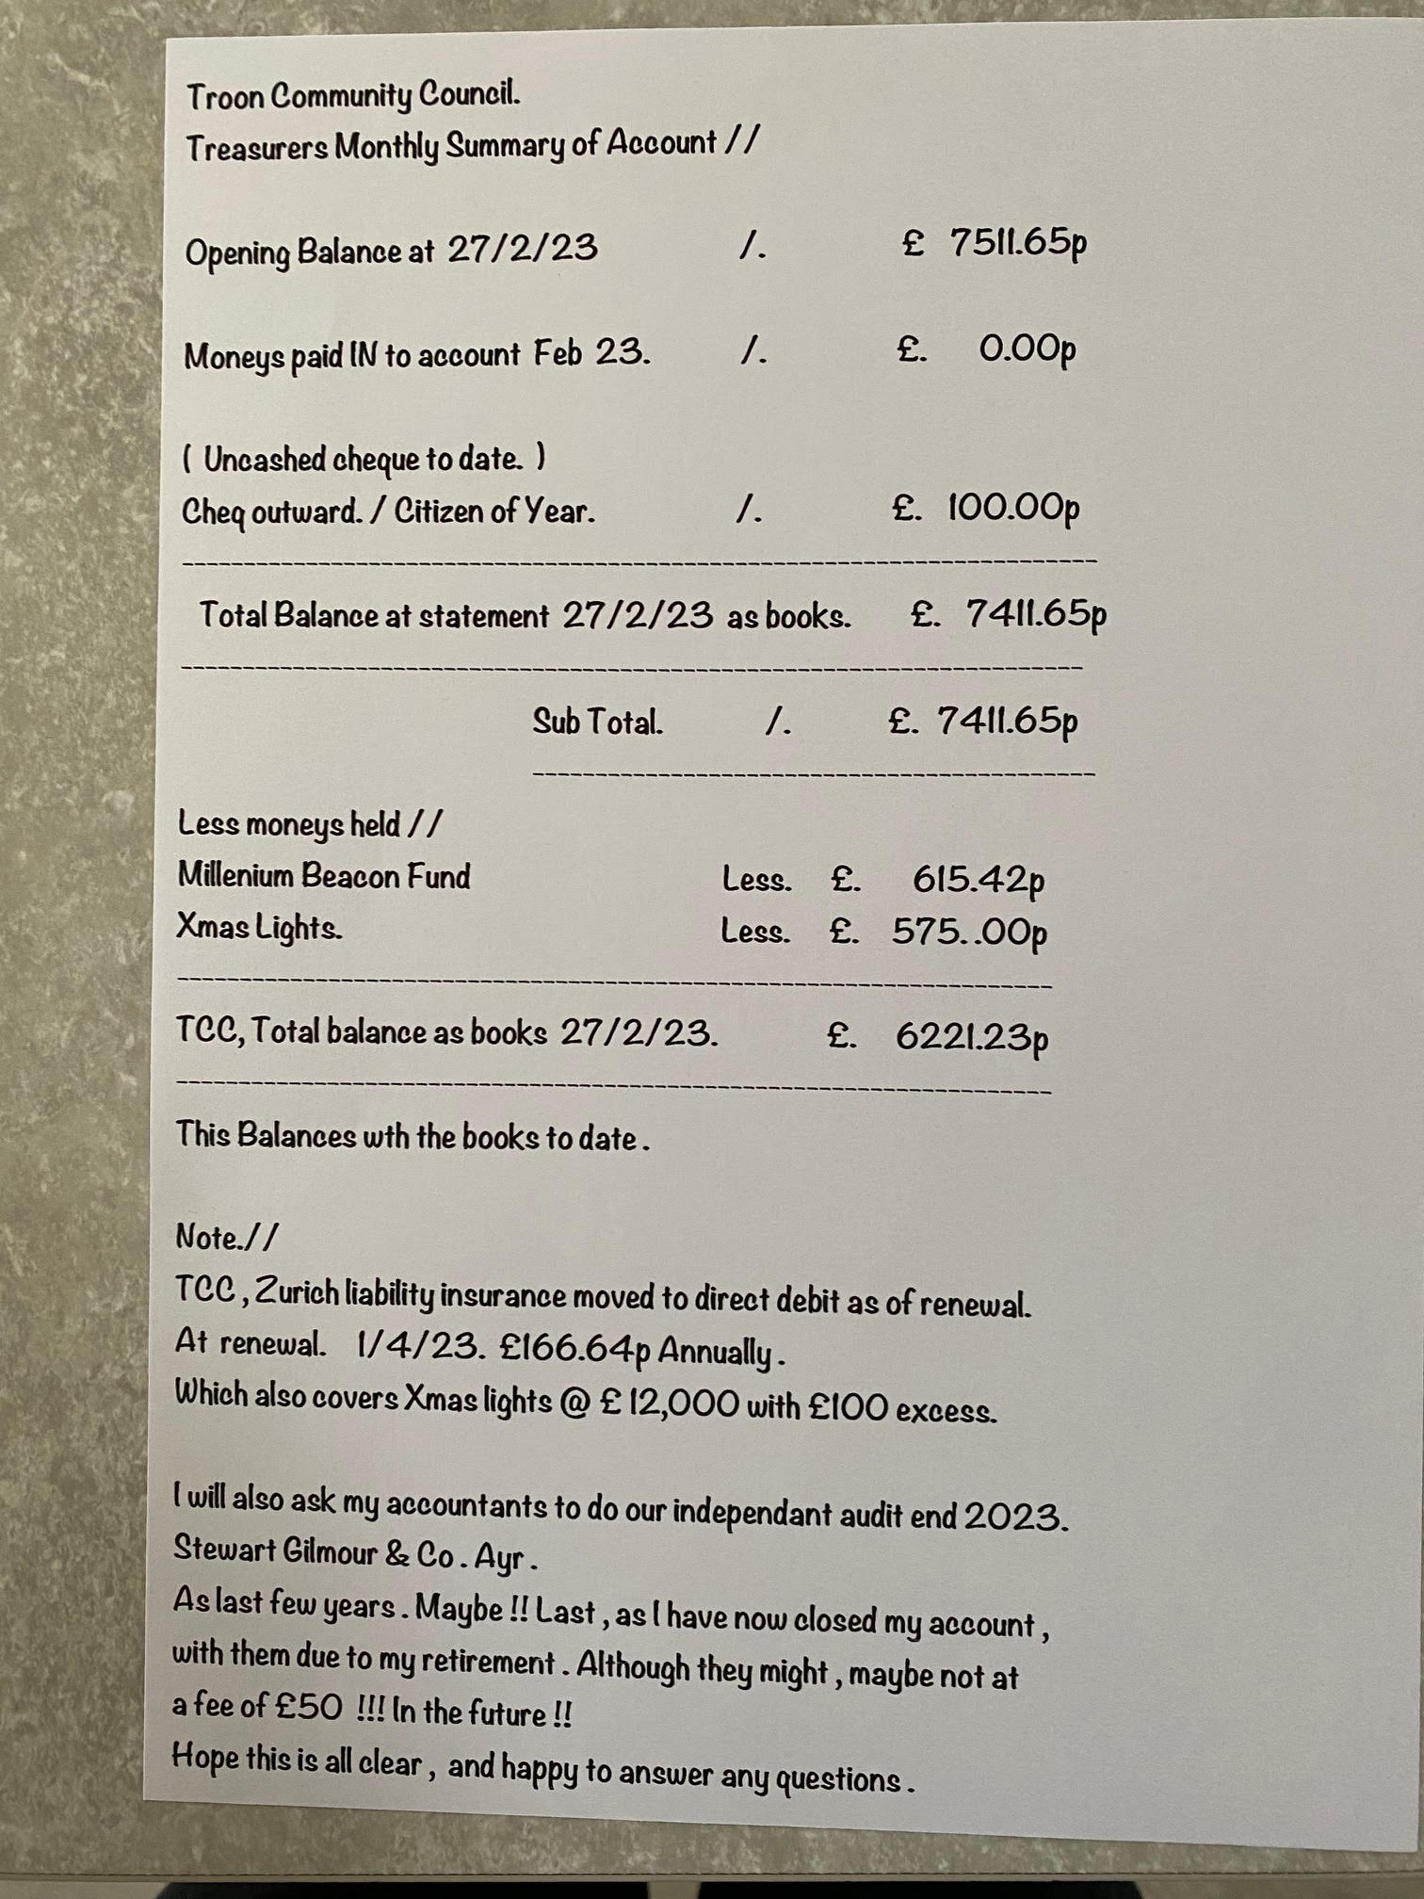

- POLICE REPORT Appendix C

Community Council Meeting: | Troon
Date: | Mar 2023
Officer Attending: | Report submitted
The information below covers the period from 06th February 2023 to 01st March 2023 with details provided in relation to the local priorities highlighted in the 2021-23 Local Police Plan for South Ayrshire.
Specific figures, stats and trends will continue to be provided at the Senior Management Scrutiny Board via the Partnership Panel.
- Serious and Organised Crime – (including Violence, Drug supply, Sexual Crime) | Violence  For the reporting period, officers have dealt with 1 report of assault, alcohol was a factor and minor injuries sustained. Enquiries continue.  Drugs Supply  Proactive work targeting drug supply is ongoing, for the reporting period we have again received 6 calls from the community providing information in relation to drug activity. In relation to the calls received, information has been pulled and entered into our intelligence database.
- Safer Communities (including Hate Crime, ASB, Domestic Abuse) | Nil  Anti-Social Behaviour (ASB)  A more positive report with regards to ASB type calls with a considerable drop in the number of calls being made.  Officers have dealt with 3 disturbances; all required an immediate policing response however all were resolved with no charges against any person. 4 reports of Public Nuisance – these related to youths causing annoyance and 2 report of dirt bikes being used at Darley Golf Course.  We continue to review reports of noise complaints and neighbour disputes, for the reporting period officers dealt with a high number of calls in relation to this. Work is ongoing to make efforts to resolve the ongoing issues. Work is ongoing between the Police ASB Team and South Ayrshire Council’s Housing team and ASB Team.  Domestic Abuse  This area of policing continues to be an area of focus, officers provide support to victims and ensure with consent of the victim they are referred to support agencies.
- Acquisitive Crime | Housebreaking  Robbery  Fraud | We have dealt with 2 reports of housebreaking 1 which involved a garage being broken into, no further lines of enquiry and no suspects identified. The other relates to St Ninians Rectory being broken into and items stolen. Enquiries are ongoing. Residents are reminded of home security.  Nil  Nil
- Community Wellbeing | Substance Use  We deal with a high number of incidents whereby substance misuse in relation to alcohol and or drugs is a factor. We work alongside partner agencies to refer individuals for further support.  Children & Young People  Nothing to report on of note for this meeting.  Welfare Concerns  We continue to respond to a high number of these types of incidents, which often take up a considerable amount of time of officers. These incidents can vary from persons suffering from mental health concerns to elderly members of the community requiring assistance. For the reporting period, we dealt with a high number of incidents with many of them requiring an immediate response. We work alongside partner agencies to deal with the incidents in a timeously manner as possible ensuring individuals speak with the relevant agency.
- Road Safety (Drink / Drug Driving, Speeding, Disqualified / Uninsured Driving) | We continue to receive a number of reports in relation to road safety. These range from speeding complaints, parking complaints, vehicle breakdowns.  For the reporting period, 1 driver was charged with driving without relevant insurance and vehicle was uplifted by officers and also 1 driver was arrested for driving whilst intoxicated.
Up-coming events | Future events officers will be involved in include women’s 10k race in May, meetings have been scheduled and locality officers will assist at the event.
Other Matters / appeals | From the last community council held in Feb 2023, reports were made of speeding cars on Bentinck Road and South Beach Road, Troon – officers attended both locations and 4 tickets were issued to speeding motorists.  Also, the campus officer was made aware of complaints re: bins being knocked over in Merrick Avenue by youths at school lunchtime, PC Harrower carried out patrols with no issued identified and confirmed the school have not received any complaints from residents.

- TCC REPORTS.

- Youth Forum.
- Nothing to report.

- Events.
- Notes from Events meeting held on 14th February 23 Appendix H
- GM raised issues over easter egg event licensing.
- Raised an issue with Walter over firms want to pay direct to TCC for the competition.
- I will update businesses over the taxi day.
- Update on Gala Day.
- PS asked for update on licence for the Gala Day.
- Events meeting next Tuesday 14th March.

FC confirmed that the tiara will be returned by the last Gala Queen.

- Planning.
- Planning proposal for 49 St Meddans Street ref 23/00116/MSC.

A vote was taken to support the objection. AP 1 submit the objection.

- Licensing.
- PS has sent all documentation for the licensing for the easter egg event. Waiting on updates from SAC

- Troon Heritage.

GM – Contacted Marr College, Ray Anderson, they are happy to help us. The pilot is ready and the second one is ongoing. We are editing these as they are currently to long. We will be doing lifeboats and Marr Rugby club.

We are looking int creating a You Tube channel in the future.

- Web Page and Email update.

AM – still having issues with the web page over mobile phones.

- Everythingtroon linking TCC to this site. Agreed that BM write refusing request AP2 BM.

- ARA North Drive Cycle Route.

AP3 Completed.

- Network Rail Troon Station. Appendix G

Planning application submitted.

- Cal-Mac Ferry.
- Invitation to Visit Troon East Pier Ferry Terminal Again 10:30 17th March Arran House

- Christmas Lights Storage.
- Zurich Insurance Appendix J

- SAC REPORTS & DISCUSSION

- Phil Saxton

Nothing to report.

- Craig McKay

Skate Park will start next week. Camper Van trial is extended to double the sites and use Barassie.
Titchfield road was proposed but not agreed. Discussed the Age Friendly Communities and problem storing the bikes.

Queens Drive problem with parking on grass.

Issues with traffic lights on Templehill.

- Kenneth Bell

Been in contact with the school to deal with litter. The fence at Scott Crescent is broken again. We need to look if the fence is fit for purpose. We need to look at directing them away from the fence.

Glad that George has had contact with the school. I met with the captains who are keen to get involved. They came up with an idea to locate QR codes throughout Troon where people can scan this tom their phones.

A discussion was held over holding the MRTA quiz in the school, this could help raise funds.

Dementia Ayrshire cycling there is an event next Tuesday.

The Ferris wheel is coming back to Troon.
Green spaces project no further information.

Waste management and paint disposal, there is an issue paint is not accepted at the recycling plants.

A78 trunk road and litter this is cleared 3 times per year.

- Bob Pollock

Darnley burn to be cleaned up in April.

Phase three cycle route Loans have no issue want it extended to behind the Loans Hotel. ARA will come back to TCC with new proposals.

- AOCB

- Marie Oliver from VASA has asked to come along to a TCC meeting to give a presentation on “Ageless and Active Champions Board and Age Friendly Communities”. AP 3 BM write to invite.

- CHAIR CLOSES MEETING.

- 4th April 2023. AGM.

