
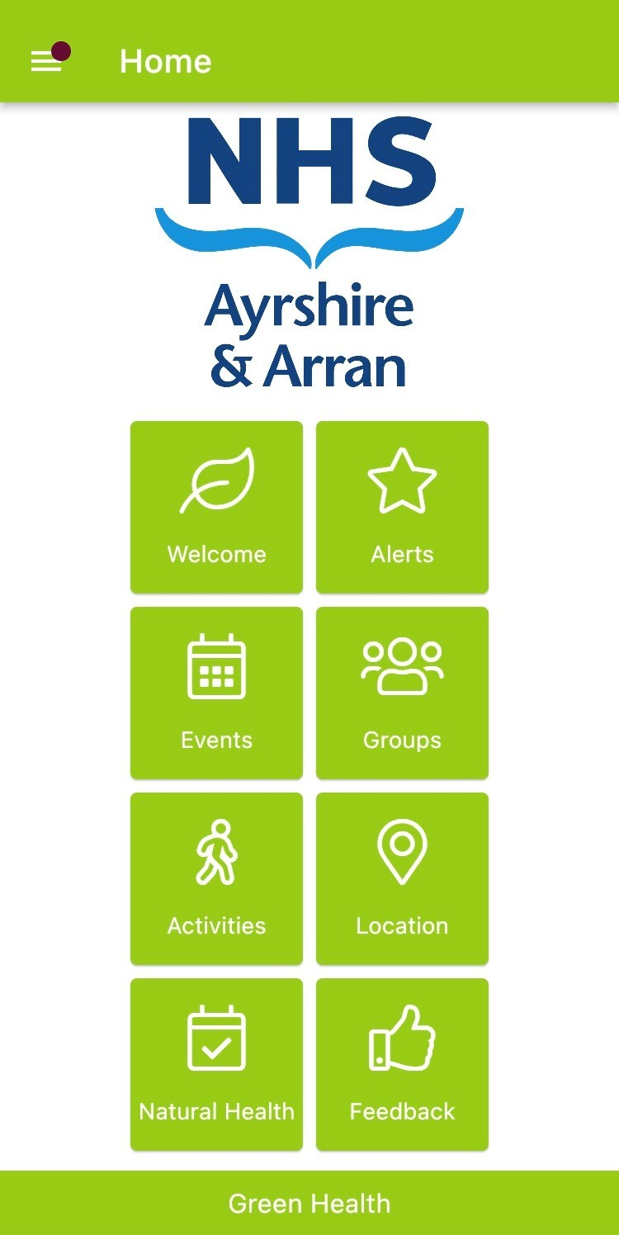
Green Health App

Contact for administration purposes
These details WILL NOT appear on the Green Health App.
RETURN THIS FORM AND AN IMAGE (Jpeg or png file) TO: | Ayrshire_NaturalHealth@nature.scot
Name: | Jenny Hunter
E-mail Address | jenny@cragcommunityarts.org
Phone Number

These details WILL appear on the Green Health App, each section is mandatory.

About the organisation
Organisation or group name / name of Activity | Crag Community Arts
Address | The Wee School Art Space,  15 Henrietta Street  Girvan
Postcode | KA26 9AL
Telephone description e.g. reception | none
Telephone number(s) | none
Contact Name for activity
E-mail address (for public to contact) | info@cragcommunityarts.org
Website address (if applicable) | https://www.facebook.com/cragcommunityarts/  (new website is under construction)
Summary of what your activity entails & how people get involved. | Upcoming workshops and events  Upcycling workshops with Victoria Randlo  Wednesdays 6th September - 11th October 12.30 - 4.30pm  These free drop-in workshops are to give you the confidence and skills to get the most out of your clothes and furnishings, helping save money and reduce waste at the same time.  6th September - Lampshade Covering  13th September - Clothing Alterations  20th September - Upcycled bags or scrunchies  27th September - Work smock dress upcycling  4th October - Visible Mending  11th October - Chair/stool upholstery  Please bring your own fabric and chairs for the upholstery workshop.  This is a drop in workshop, so no need to book.  For Ages 16+  This is a free workshop, donations welcome.  Sustainable Fashion Week - 27th September - 8th October  Sustainable fashion week is a national campaign to raise awareness of the environmental impact of the fashion industry. In support of this campaign we are running workshops with a sustainable textile theme.  Monday 25th - Upcycle Embroidery with Eva Harold from Slow Stitch Studio  This session is running during the weekly Making Mondays Group which runs every Monday 1.30pm - 3.30pm. Learn how to give clothing and accessories a new lease of life using creative embroidery techniques.  For ages 16+  This is a drop in workshop, so no need to book.  For Ages 16+  This is a free workshop, donations welcome.  Sew your own T-Shirt with Alexis Campbell  Wednesday 27th September and Wednesday 4th October 6pm - 9pm  Learn how to make your own T-Shirt to your size in this beginners workshop which runs over the course of 2 weeks.  Please book via Eventbrite. For ages 16+. https://www.eventbrite.com/e/sew-your-own-t-shirt-tickets-717691924867?aff=oddtdtcreator  Beginners Crochet for Kids with Sarah McLeod of Hyperbolic Textiles  Saturday 30th September 10am - 12noon  Learn the basics of freeform crochet in this exciting beginners workshop where you will also learn to make your own yarns from repurposed every day textiles.  For ages 8-16.  Please book via Eventbrite.  https://www.eventbrite.com/e/crochet-for-kids-tickets-718395990747?aff=oddtdtcreator  Lantern making workshops  The carnival of light lantern parade is back and the lantern fowk are out to play. Come along to one of our free drop in workshops and make your own lantern for the parade. See flier.  All of these workshops are free, although donations are most welcome.  Weekly Groups @ The Wee School Art Space  Making Mondays  Mondays 1.30 - 3.30  Crafting Group where you are welcome to bring your own project, try new crafts, and have a chat. A selection of preloved materials are available for use for a small donation.  Growing Together Gardening Group  Tuesdays 11am - 1pm  Volunteer gardening group, join us to help create a community growing space here at The Wee School Art Space. No experience required, just a willing pair of hands.  Girvan Community Choir  Tuesdays 7pm - 9pm  Join our friendly choir to learn a mixture of traditional and contemporary songs led by experienced choir master and pianist Andrew Thom.  Paint n' Patter  Thursdays 11am - 4pm  Drop in to our Paint n' Patter Studio, this friendly and supportive art group is suitable for all skill levels and a great opportunity to learn from each other and experiment with new materials. You are welcome to bring a project from home or start something fresh. We have a range of art materials available to use and canvases are available for a small donation.
Upload an image file jpeg or png (not more than 5MB)

