Briefing Note – Loans to Troon Phase 3 Active Travel Route
Date of Issue | Briefing Note
May 2023 | Loans to Troon Phase 3 Project Notification Briefing Note
August 2023 | Loans to Troon Phase 3 Project Update 1 Briefing Note
May 2024 | Loans to Troon Phase 3 Project Update 2 Briefing Note

Loans to Troon Phase 3 - Project Update 2 Briefing Note (May 2024):

Following feedback from the elected members, the design proposals were finalised on 08/02/2024. The elected member group granted approval to progress to public consultation with a preferred option. Subsequently, the public consultation took place at Muirhead Community Centre on 04/04/2024. In addition, a project website was made available for the public to view during the consultation period, with the option to provide feedback via a project-specific email address.

During the in-person event, 67 individuals attended and provided a diverse range of feedback. The majority of the feedback pertained to on-street parking provision and the previous proposals that included more significant changes to the road network. These comments had been raised in previous consultations as well. However, a new comment from a resident raised concerns about the short section of widened footway into the carriageway at the western end of North Drive and its potential impact on driveway access and egress. It is important to note that the proposals prioritise driveway access throughout the entire scheme.

For a detailed view of the final concept design plans for the scheme, please refer to Appendix D.

Loans to Troon Phase 3 - Project Update 1 Briefing Note (August 2023):

All Loans to Troon Phase 3 design options drawings for Stage 2 (Concept Design) have been presented to the elected members for feedback. The elected members have subsequently accepted the recommendations for the preferred option (1b) in principle, however, a request has been made to organise a follow up session to answer any design related queries. Following this, a further round of consultation will take place with the local community to ensure that the designs meet the expectations of the public and the project can progress to the next stage of design.

Loans to Troon Phase 3 - Briefing Note (May 2023):

This document provides an executive summary of the design options explored, explaining the rationale of each one, for Phase 3 of the Loans to Troon Active Travel route. This scheme has already seen Phases 1 & 2 successfully constructed.

Phase 3 is the completion phase of the project and aims to connect Phase 2, ending at the north end of Buchan Road, outside Muirhead Primary School to the settlement of Loans, as shown below in Figure 1.

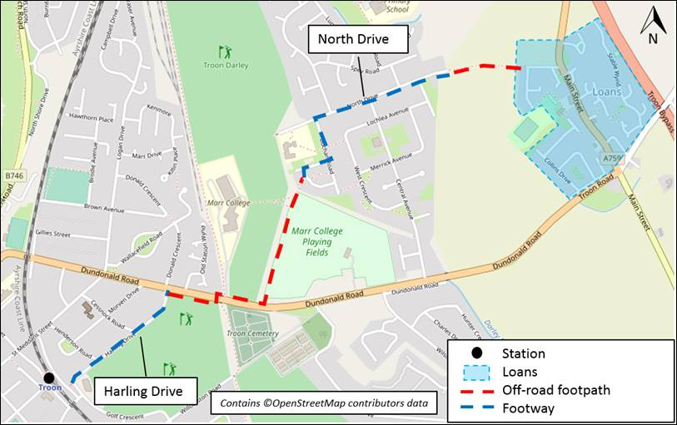
Figure 1: Full route proposal

Executive summary

Whilst it is appreciated the route for Phase 3 rests with ARA, though based on the engagement results, Sweco’s thoughts from an active travel specialist are detailed throughout this document.

Having considered all the feedback from recent consultation (ending in January 2023 and report contained in Appendix C), the key themes listed below were drawn out;
- Residents are strongly opposed to a one-way system on North Drive
- Removal of on street parking is a concern for residents who have more than one car/for visitors
- Generally viewed that the number of people using the completed phases 1 & 2 did not justify the need for dedicated cycle tracks on either North Drive or Lochlea Avenue, subsequently meaning there was insufficient demand for fully segregated cycling infrastructure
- A lighter touch would be more appropriate – reduce speed limit, traffic calming (build outs/raised table)
- Preferred concept is a shared use path on North Drive owing to it being more direct

Taking the above, and results from previous consultation, into account combined with the SWOT analysis undertaken for the routes described throughout this document, it would be the recommendation that North Drive Option 1.a be progressed.

Having a shared use path on the north side would be the most direct route whilst allowing both pedestrians and cyclists to use this side of the street.

Project Background
A feasibility report, produced and written by Sweco in March 2019 identified the full scheme route in Figure 1 as the most favoured, based on feedback from stakeholder engagement, undertaken in January 2019.
The stakeholders involved in this initial consultation consisted of; Troon Community Council, Loans Community Council, South Ayrshire Council, Marr College and SAPI.

Following completion of Phases 1 & 2, public consultation for Phase 3 was carried out between September and October 2021 through an online ArcGIS Hub and questionnaire. This had a focused approach of: (i) stakeholder targeted engagement and (ii) location-orientated public consultation.
The process followed between September 2021 and present (Feb 2023) is outlined in Figure 2 below.

The main themes drawn out from the initial consultation in 2021 were:
- Walking is the second most common form of transport, after car/van use for commuting to and from work
- The highest ranked factor in order of importance (from the choices available) for secondary barriers to cycling was ‘children can walk and cycle safely’. ‘Long distance to travel’ was the main prevention for over half the participants
- 33% of respondents said they would be likely to use a dedicated walking/cycle path to school

The results from this round of consultation were analysed and documented in the Community Engagement report, produced in April 2022. The report concluded with two route corridors being identified for further consideration and development.

Concept designs were produced based on the responses and comments received during this initial public consultation period.
These designs were presented to the public using online story map in May & June 2022, affording the opportunity for feedback, which was generally negative.

Based on the negative public response, Sweco were further commissioned to undertake a second round of Phase 3 public engagement between October 2022 and January 2023, resulting in a reiteration of concept designs. This round of engagement included two in person workshops sessions, outlined in Figure 2.
An addendum to the April 2022 community engagement report has recently been produced to include the second round of consultation (Appendix C).

Online consultation page (Survey & Interactive map) live

30th September 2022 – 31st January 2023

Figure 2: Engagement Story Map

Design Options
Taking cognisance of the themes outlined in sections 1 and 2 of this document, the below describes the route corridors, concept options and relationship of each option to the themes.

Route Corridor 1 – North Drive
Route Corridor 2 – Lochlea Avenue

North Drive has three potential design options, while Lochlea Avenue has one. These are;

North Drive - Op1.a - Shared Footway
North Drive - Op1.b - Shared Footway with Modal Filter
North Drive - Op2 - Bi-Directional Only - Two-Way Road
Lochlea Avenue - Op1 - Bi-Directional One Way Road (Eastbound)

North Drive Option 1.a – Shared Footway
This option proposes widening the existing footway on the north side of North Drive to create a 3m wide shared use footway, whilst retaining the existing 1.6m wide footway on the south side.

The proposal would see the existing carriageway narrowed to create a 6.5m wide two way system, achieved by altering the location of the existing kerbline along the south side of the carriageway whilst retaining the existing footway.
The existing driveways (shown as blue hatches in Figure 3 below) interspersed with driveway crossings and associated kerblines would be removed to achieve this.

An extract of the proposal is shown below in Figure 3.

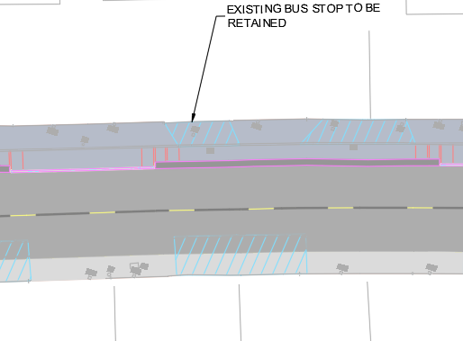
Figure 3: Extract of North Drive Option 1.a proposal
In order to control traffic speeds, three raised tables are proposed; namely at the North Drive junctions with; Deveron Road, Afton Gardens and Earn Road.

This option would meet theme 1,3,4 & 5 in section 1 of this document.
Whilst this option is not removing on street parking as such, narrowing the carriageway could impact traffic movement whilst retaining on street parking.

North Drive Option 1.b – Shared Footway with modal filter
This option proposes the same infrastructure as above but with the addition of modal filters, in order to create a quiet street.
This option was explored, however the traffic data collected shows the highest volumes are between Afton Gardens and Deveron Drive. In order to effictivey reduce traffic voulmes, it would be recommended a modal filter would need to be implemented between these streets, which would seem impractical.
Initial thoughts were a modal filter could be installed between Afton Gardens and Earn road but based on the traffic data, this would have minimal impact.

There are various options for modal filters including planters, bollards and light segregation bollard units.
There is also the option of using this as a trial – provided temporary infrastructure such as light segregation bolt in kerb and bollard units are used.

North Drive Option 2 - Bi-Directional Only - Two-Way Road
This option proposes a 2.6m wide, bi-directional cycleway on the north side of North Drive incorpororating a 0.5m wide buffer zone, shared use areas at junctions and dutch style ramp kerbs for driveways.
A 2m wide footway is proposed for the south side, utilising and widening the existing footway.
The carriageway would be a 6.5m wide two way system, again, being achieved by removing the grass verges and altering the kerbline on the south side of the carriageway.
An extract is demonstrated in Figure 4.

Option 2 would permit cyclists only to use this side of the street therefore restricting pedestrian movement.
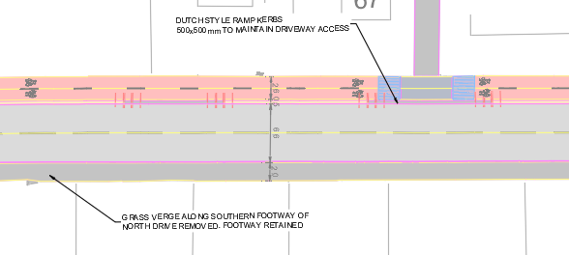
Figure 4: Extract of North Drive Option 2 proposal

If the speed limit of North Drive were reduced to 20mph (as is proposed across all options) then it is is likely the buffer zone could be removed.

This option would create some consistency with Phases 1 & 2 in the way of bi-directional segregated cycle way however, owing to the nature of North Drive, the segregation itself would create an inconsistent experience for the user.

This option counters the key themes outlined in section 1 of this report.

Lochlea Avenue – Option 1 - Bi-Directional One Way Road (Eastbound)

This proposal sees a combination of shared use and segregated bi-directional infrastructure in conjunction with a proposed narrowed carriageway and the creation of a one way system for motorised vehicles.
The route connects Buchan Road to West Crescent using an existing 2.5m wide footpath, where a proposed 3.4m wide shared use path runs north – south up West Crescent.

A proposed 2.5m wide segregated bi-directional cycleway with a 1.6m footway to the rear then runs east to west along Lochlea Avenue and north-south up Aldersyde Avenue.
Shared use areas are proposed at the junctions where Lochlea Avenue meets with Central Avenue and Aldersyde Avenue, and where Aldersyde Avenue meets North Drive.

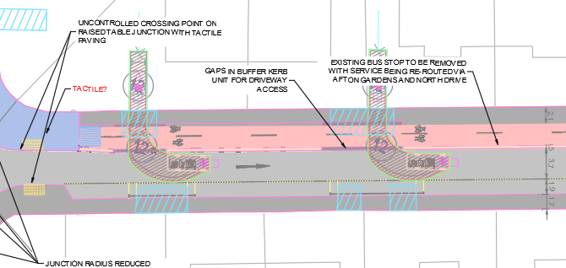
Figure 5: Extract of Lochlea Avenue Option 1 proposal

This proposal would be achieved by widening the existing footway on the north side of Lochlea Avenue, narrowing the existing carriageway (the subsequent requirement for a one way system) and removing the verges along the south side, with formalised parking areas proposed.

Lochlea Avenue is a less direct route and would incur several busy junction crossings – particularly at the Lochlea Avenue/Central Avenue crossroads.
With Lochlea Avenue being a current bus route, engagement with bus companies could be deemed a significant project risk if this option were to be progressed.

Next Steps
Following the production of this document the updated concept designs, community engagement report and this briefing document will be sent to Ayrshire Roads Alliance and elected members for consultation.

Feedback will be taken on board and the designs progressed accordingly where practical.

There is the possibility of extending the scheme into Loans which could potentially be captured, as a Phase 3a, as the designs develop.
Going forward, it would be intended to develop the Loans extension to the same standard as the current Phase 3 and undertake further consultation covering both sections.

Concept designs will be produced with the intention of progressing to RIBA Stages 3 & 4, which are the developed design and technical design stages.

Appendices

Appendix A: Concept Design Drawings
Appendix B: SWOT Analysis
Appendix C: Community Engagement Report
Appendix D: Final Concept Design Proposals

